## Network Security Controls: Physical controls

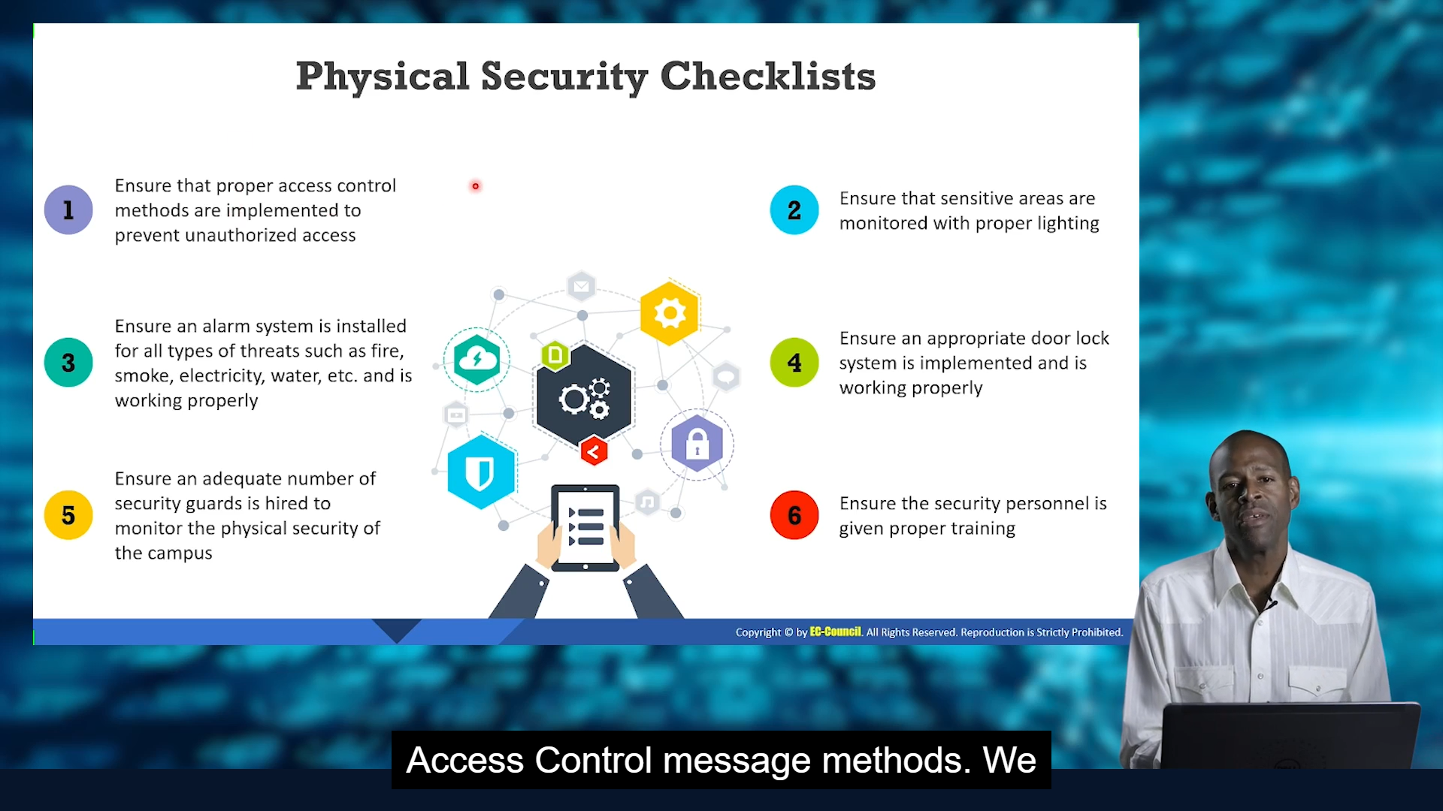

Types:

1. Preventive Controls : Prevents security violations Ex: door lock, gaurds
2. Detective Controls : records any intrusion attempts Ex: CCTV, alarm sensors, motion detectors
3. Deterrent controls : Send warning messages to intrusion attempts
4. Recovery Controls : restore information & systems from security violation to a persistent state

Ex: disaster recovery, business continuity plans, backup systems etc

1. Compensating Controls: alternative control when intended controls fails

Ex: hot sites, backup power systems or UPS

Location Considerations:

Visibility of assers

Neighboring buildings

Local considerations

Impact of catastrophic events

Joint tenancy risks

# Site Architecture Considerations

**Network Infrastructure Placement:**

* **Secure locations:** Network equipment like servers, routers, and switches should be placed in secure, dedicated rooms with restricted access

**Ex:** Server room

* **Environmental controls:** to prevent overheating and ensure optimal performance of n/w equipment..
* **Physical separation:** physically separating critical network components like core routers or firewalls from less sensitive equipment. This can help contain the impact of a physical security breach.

**Cable Management:**

* **Physical security:** Network cables should be routed strategically to avoid tampering or accidental damage. This might involve using conduits, overhead trays, or secure cable management systems.
* **Labelling:** Clearly label all network cables for easier identification during troubleshooting or maintenance. This can indirectly improve network security by making it more difficult for unauthorized individuals to manipulate cables.

**Data Center Design (if applicable):**

* **Raised floors:** Data centers often utilize raised floors to allow for better cable management and airflow beneath the equipment racks. This raised floor area should be secured to prevent unauthorized access to network cabling.
* **Power redundancy:** Implement redundant power supplies and backup generators to ensure network uptime even in case of power outages. Physical security of the power supply infrastructure is crucial to prevent disruptions.

**Overall Site Considerations:**

* **Building access control:** As mentioned in physical security considerations, restricting access to the building where network equipment resides is the first line of defense. This includes controlling access to server rooms and data centers.
* **Security awareness:** Training staff on physical security protocols like not tailgating authorized personnel into secure areas can indirectly improve network security by minimizing the risk of unauthorized access to network equipment.

# Fire Fighting Systems

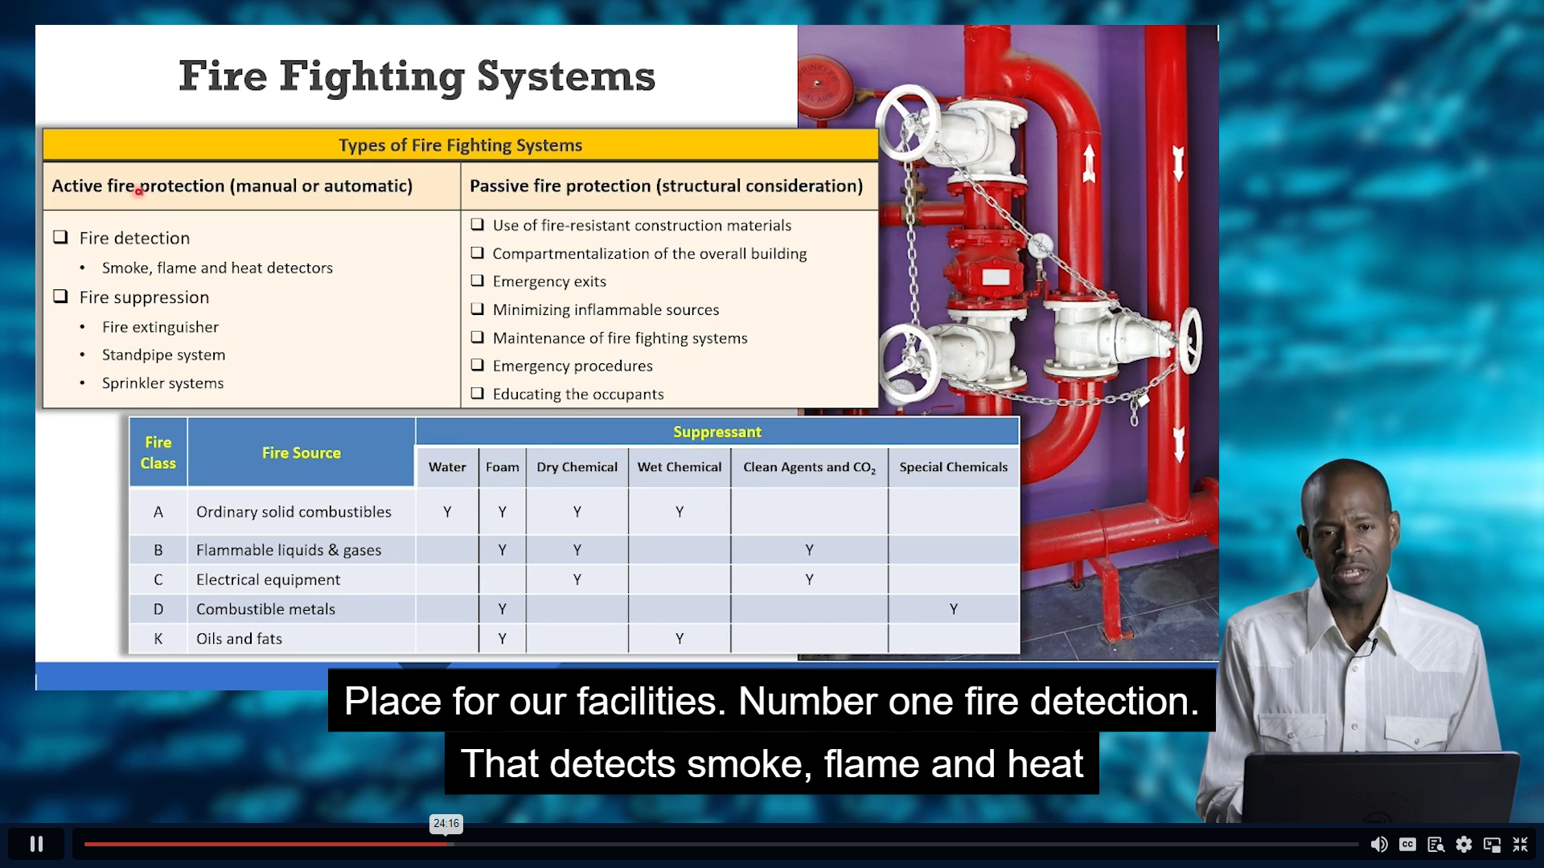

# Physical Barriers

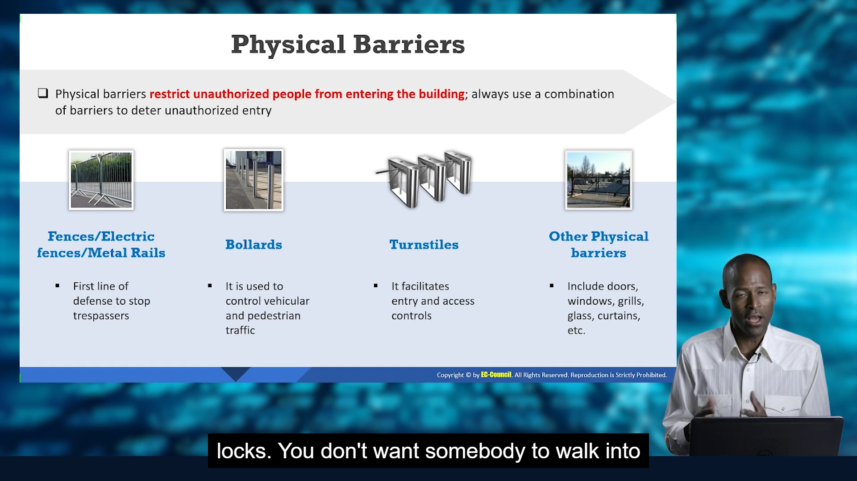

# Security Personnel – Gaurds, security officer, supervisor

|  |  |  |
| --- | --- | --- |
| should be aware | | |
| Physical security policies and procedures | Handling emergency situations | Patrolling procedures |
| First aid & medical assistance | Fire prevention | Trespassers & crowd management |

# Physical Locks :

* Mechanical
* Combinational
* Digital
* Magnetic/ Electromagnetic : operated by magnets, solenoids and motors by giving power

# Concealed weapons/ Contraband Detection devices: Used by Federal agencies

* Metal detectors
* Xray- inspection
* Walk-through metal detectors

# Mantrap

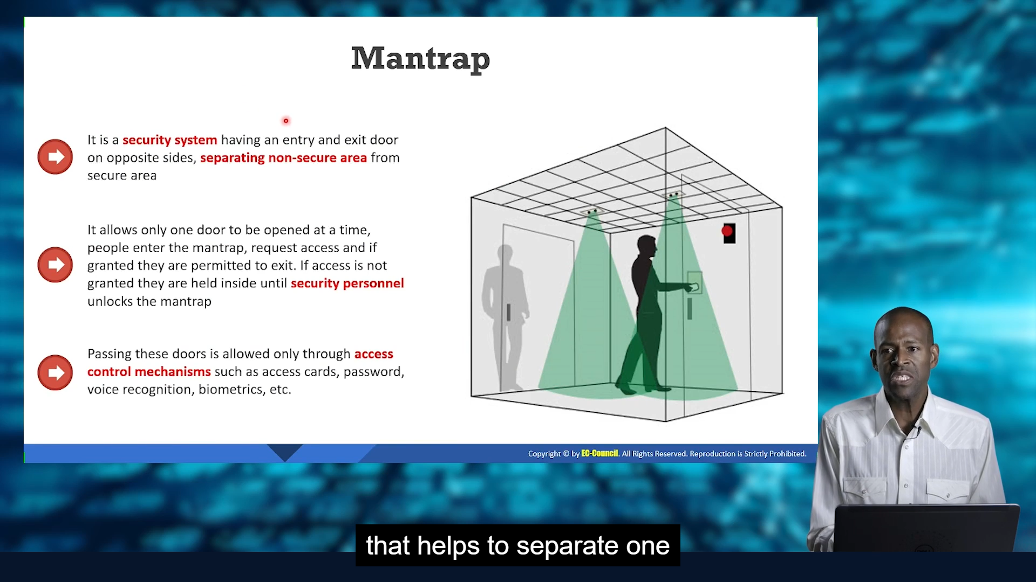

# Warning signs:

Like restricted area

Should be placed at each control point

# Alarm systems & CCTV , Lightning system

They can be triggered by CCTV

Types of lighting systems:

* Continuous
* Standby
* Movable
* Emergency

# POWER SUPPLY

## TYPES OF UPS SYSTEMS (Uninterruptible power supply)

* Standby : Used for PC’s
* Line Interactive :Small business, web, departmental servers
* Standby on-line hybrid :Server rooms
* Standby-Ferro :
* Double Conversion On-Line :Where electrical isolation is necessary
* Delta Conversion On-Line : When complete isolation/connectivity is required

# WorkPlace security

## Reception Area

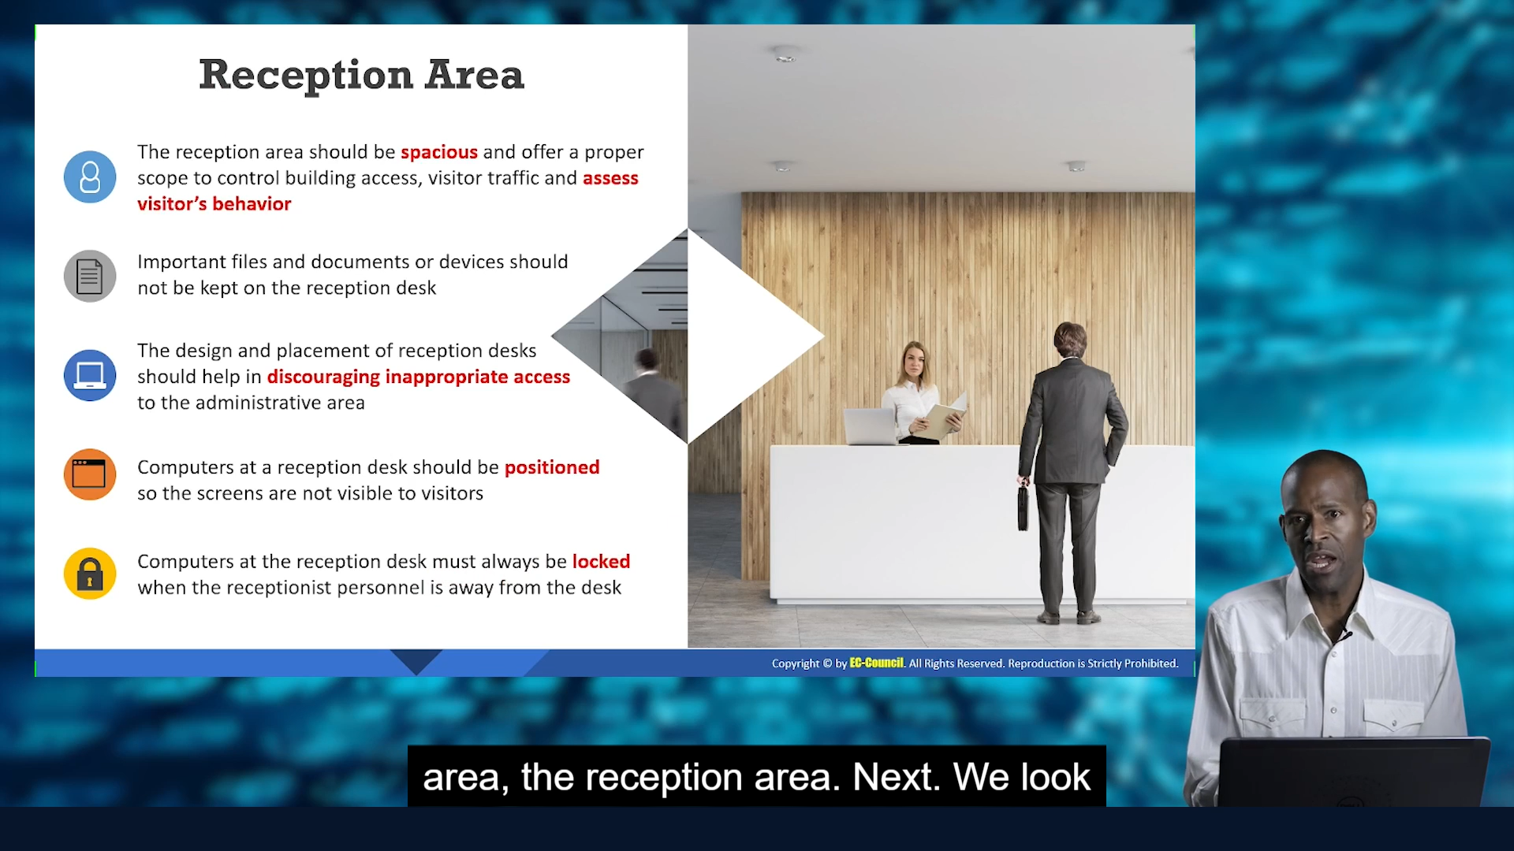

## Server/Backup Device security

* Keep critical n/w assets in separate room
* Protect with appropriate access control like Multi-factor auth(MFA)
* Keep the server room under Video surveillance

## Critical Assets and Removable Devices

* Keep n/w devices and computer equipment in locked devices with biometric locks and climate control features

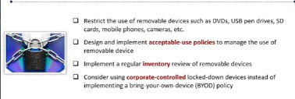

* USB ports can be sealed by hot glue guns.
* KOBO but not BYOD

## SECURING Network Cables

## 

## Securing Portable Devices

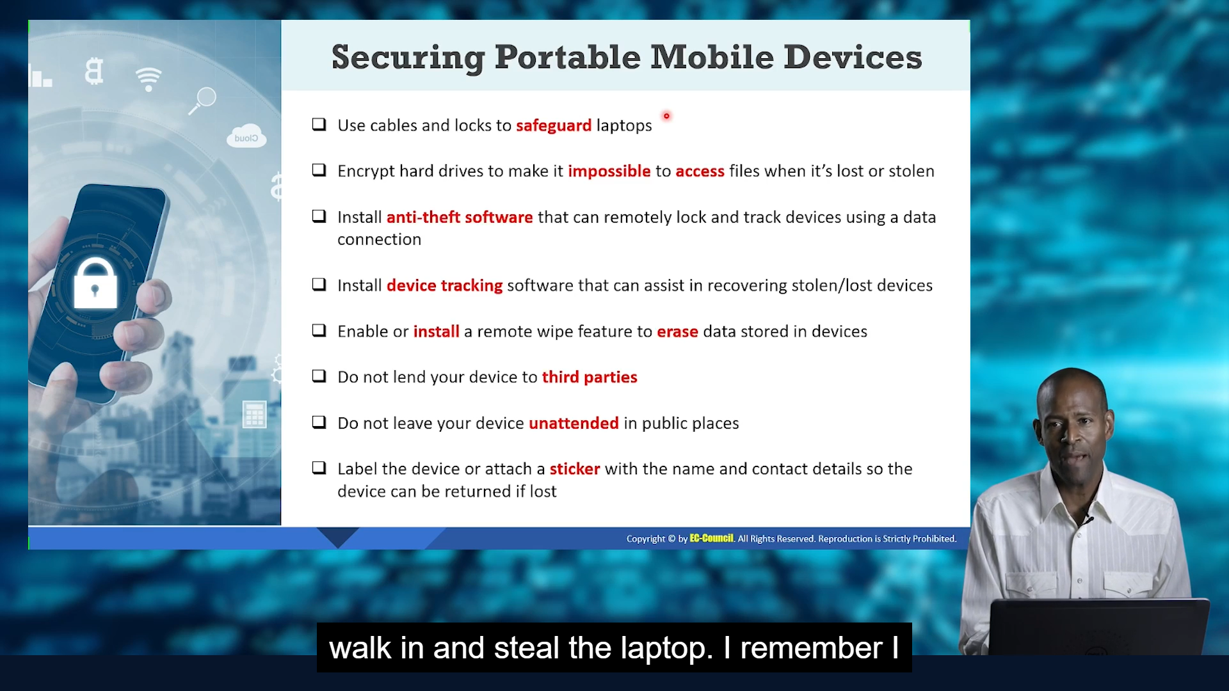

## Physical Security Policy

## 

## HVAC

• **Equipment types:** Furnaces, air conditioners, heat pumps, ventilation systems, air handlers, thermostats, etc.

• **Technical specifications:** Capacity (BTU), efficiency ratings (SEER, HSPF), airflow (CFM), noise levels (dBA), etc.

• **Installation and maintenance practices:** Proper ductwork design, refrigerant charging, electrical connections, troubleshooting techniques, etc.

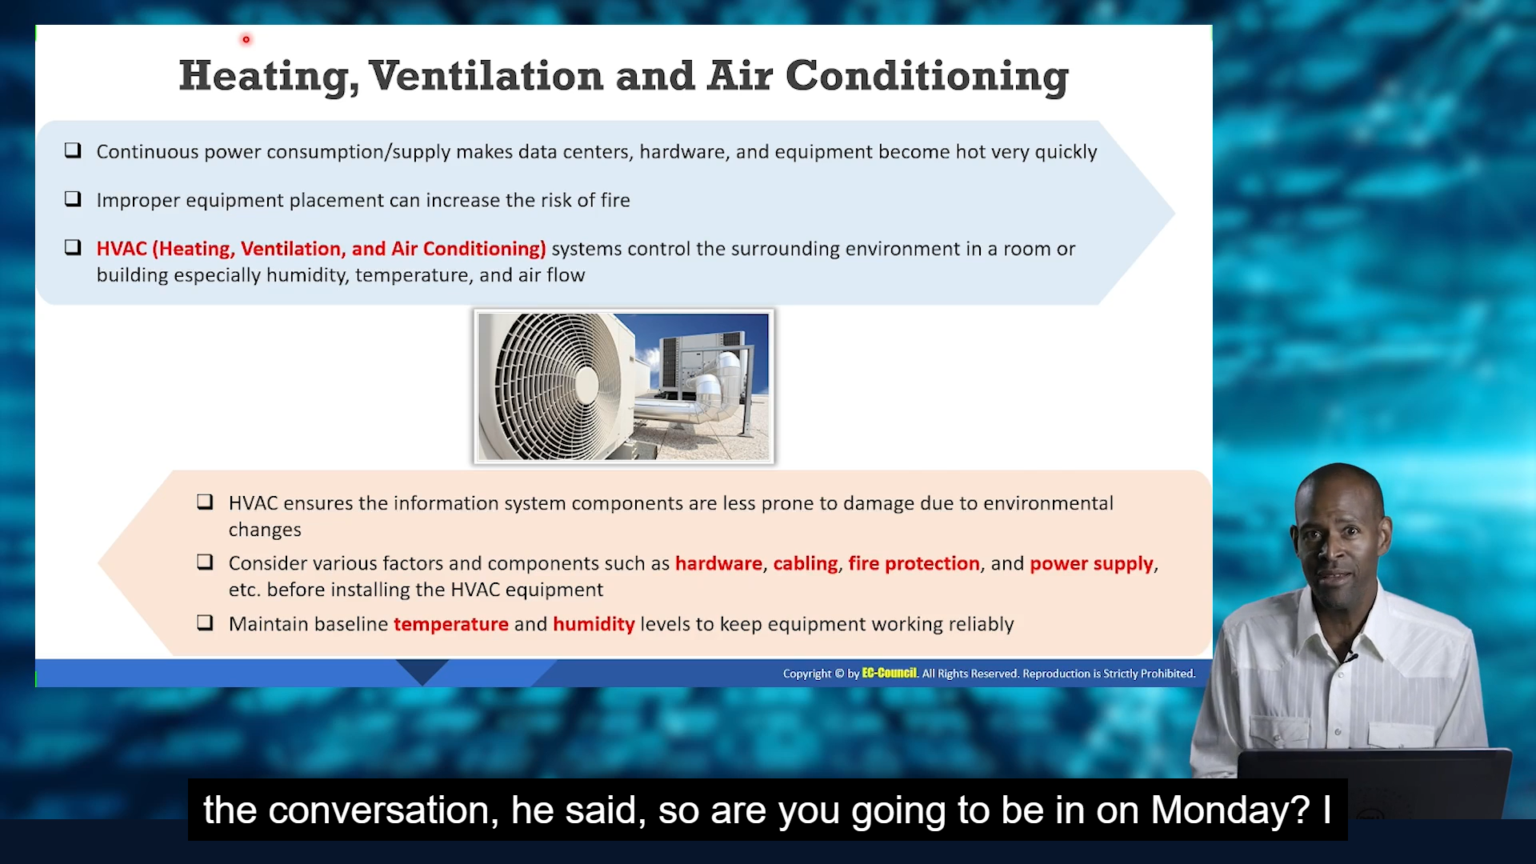

## EMI (Electromagnetic Interference) SHIELDING

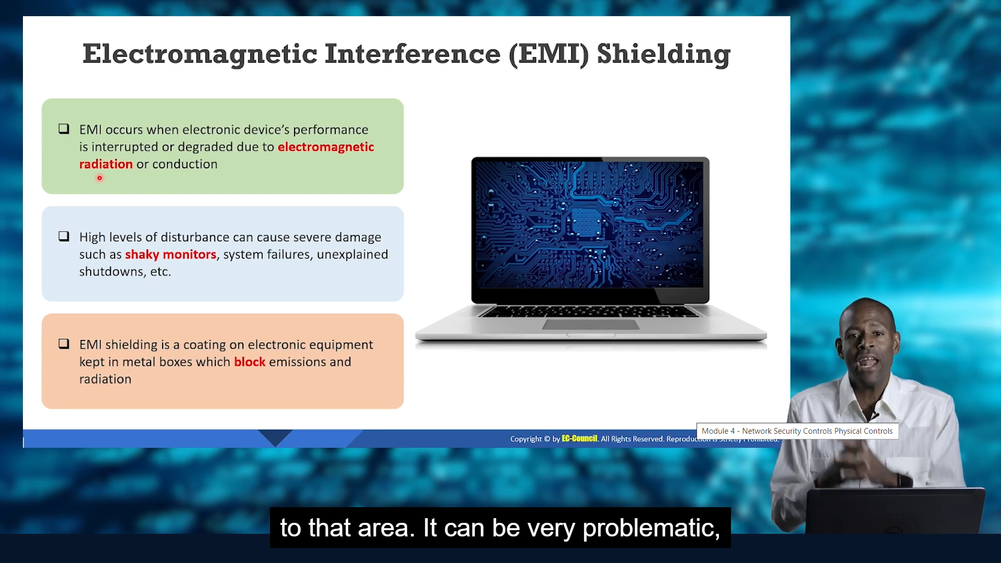

## Hot and Cool Aisles

